- \Operation\Inserting\Monitoring, product not insert
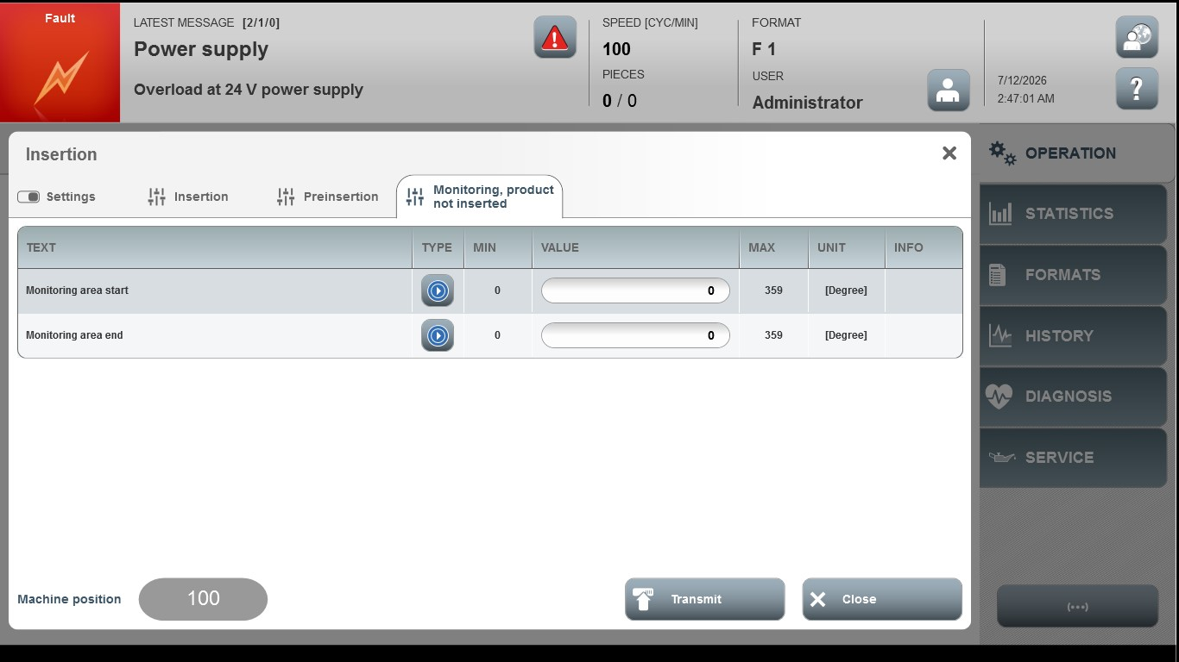

Acceptance criterion | Limits | Pass / Fail: Dev-No. | Date | Initials
Screen matches screenshot | N / A
Monitoring area start | 0…359
Monitoring area end | 0…359

